

Submitted By:
Muhammad Ahmed Subhani
SU92 – BSSEM – S25 – 018
Section: 4-A

Submitted To:
Sir Rasikh Ali

Department of Software Engineering
Superior University, Lahore
LAB 3
DLS and IDDFS
- Understand the graph
We will continue to use the same starting node (A) and end node (G) from the previous graph
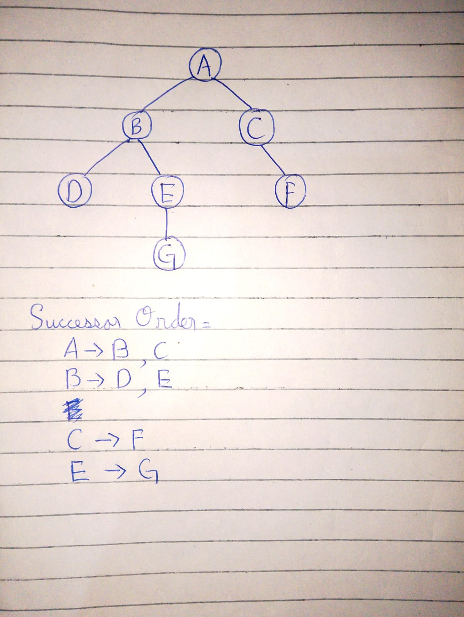

The goal G is at a depth of 3, which means that the goal cannot be reached on depth 1 or 2. It can be attained by 3 or 4.
- DLS (Depth-Limited Search):
DFS will not go past a certain depth.
- IDDFS (Iterative Deepening DFS):
It is a variant of DLS, which is run repeatedly with a growing limit value from 0 to the maximum value, until the goal is reached or the maximum value is achieved.

- Path local cycle check:
Does not allow reentering a node that has already been encountered along the current path but does not incorrectly prevent entering a node encountered by a different path.
- FOUND:
It is recorded when a goal is scored.
- CUTOFF:
Search was terminated because of depth limit with unexplored successors.
- FAILURE:
Failed to find a solution and depth cutoff not reached.
2. Results
DLS Results:
Depth limit | Status | Path
1 | CUTOFF | None
2 | CUTOFF | None
3 | FOUND | A → B → E → G
4 | FOUND | A → B → E → G
The root A has depth 0. Therefore, G at depth 3 is reachable with a limit of 3, but not with limits 1 or 2.
IDDFS Results:
Maximum depth | Status | Path | Limits attempted
1 | CUTOFF | None | 0, 1
2 | CUTOFF | None | 0, 1, 2
3 | FOUND | A → B → E → G | 0, 1, 2, 3
4 | FOUND | A → B → E → G | 0, 1, 2, 3
IDDFS stops immediately when it finds the goal. So, for the max depth of 4, it wouldn't have to do a search at the max depth of 4 since it found the goal at limit
3. Why do limits < 3 fail?
Limit 1: Search can reach B and C, but not their children at depth 2.
Limit 2: Search can be used to explore D, E and F but cannot be used to explore G at depth 3. Limit 3: Search will move to G then A → B → E → G.
Limit 4: It is found that the same path can be used; the additional depth is not needed.
Limits 1 and 2 are not FAILURE, but CUTOFF, because the search was not allowed to explore potentially relevant successors due to the depth limit.
4. Why does IDDFS repeat work?
IDDFS performs depth-limited search several times with the increasing limit. For instance, the node A is visited at the limits 0, 1, 2 and 3. Repeatedly exploring the nodes like B is also explored.
This repeated work is deliberate: The shallow-solution, breadth-first search behavior is gained at the expense of memory usage resembling the behavior of depth-first search. In this instance, it will find the shallowest goal path at depth 3.

